**Python Laboratory**

SUBMITTED IN PARTIAL FULFILLMENT OF THE REQUIREMENTS FOR THE AWARD

OF THE DEGREE OF

**BACHELOR OF TECHNOLOGY**

**(**Information Technology)



**SUBMITTED BY:** **SUBMITTED TO:**

Raushan Kumar ( 2203751 ) Prof. Reema Varma

DEPARTMENT OF INFORMATION TECHNOLOGY

GURU NANAK DEV ENGINEERING COLLEGE LUDHIANA

(An Autonomous College Under UGC ACT)

1. Create a simple web page by writing HTML using a simple text editor, Notepad. Demonstrate the following components of the web page: Page titles and Headings Paragraphs and Inline images

<!DOCTYPE html>

<html lang="en">

<head>

    <meta charset="UTF-8">

    <meta name="viewport" content="width=device-width, initial-scale=1.0">

    <title>My Simple Webpage</title>

</head>

<body>

    <h1>Welcome to My Simple Webpage</h1>

    <h2>About Me</h2>

    <p>

        Hello! My name is John Doe. I am a web developer learning HTML.

    </p>

    <h2>My Hobbies</h2>

    <p>

        I enjoy spending my free time on various hobbies including reading, hiking, and photography.

    </p>

    <h2>My Favorite Image</h2>

    <p>

        Here is an inline image of a beautiful landscape:

    </p>

    <img src="https://shorturl.at/tBFKZ" alt="Beautiful Landscape">

</body>

</html>

Output:-

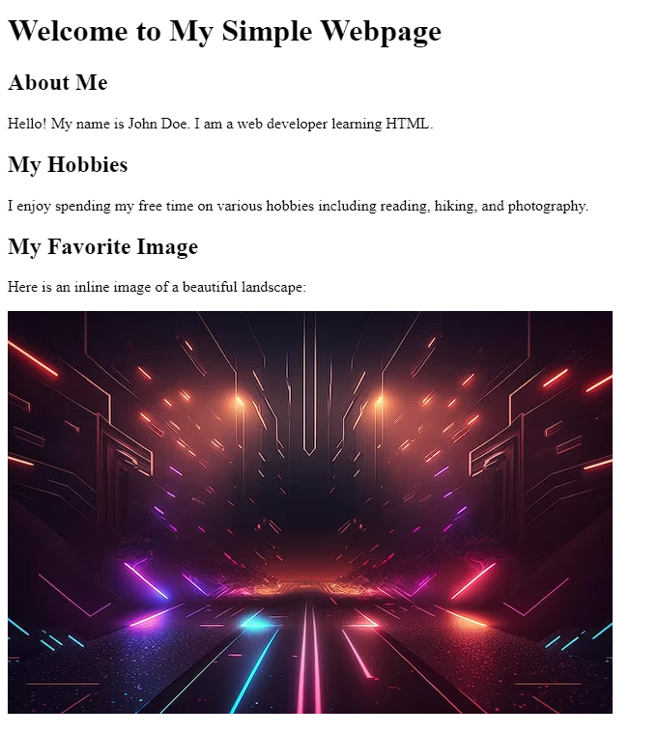

2. Demonstrate the use of Links, Lists and Tables in HTML. You should be able to link separate pages and create named links within a document, using them to build a “table of contents”.

Code:-

<!DOCTYPE html>

<html lang="en">

<head>

    <meta charset="UTF-8">

    <meta name="viewport" content="width=device-width, initial-scale=1.0">

    <title>Table of Contents</title>

</head>

<body>

    <h1>Table of Contents</h1>

    <h2>Contents:</h2>

    <ol>

        <li><a href="#section1">Introduction</a></li>

        <li><a href="#section2">Main Content</a></li>

        <li><a href="#section3">Conclusion</a></li>

    </ol>

    <h2 id="section1">1. Introduction</h2>

    <p>

        This is the introduction section.

    </p>

    <h2 id="section2">2. Main Content</h2>

    <p>

        This is the main content section.

    </p>

    <h2 id="section3">3. Conclusion</h2>

    <p>

        This is the conclusion section.

    </p>

    <h2>References</h2>

    <table border="1">

        <thead>

            <tr>

                <th>Topic</th>

                <th>Link</th>

            </tr>

        </thead>

        <tbody>

            <tr>

                <td>HTML Basics</td>

                <td><a href="html_basics.html">Click Here</a></td>

            </tr>

            <tr>

                <td>CSS Fundamentals</td>

                <td><a href="css_fundamentals.html">Click Here</a></td>

            </tr>

            <tr>

                <td>JavaScript Essentials</td>

                <td><a href="js_essentials.html">Click Here</a></td>

            </tr>

        </tbody>

    </table>

</body>

</html>

Output:-

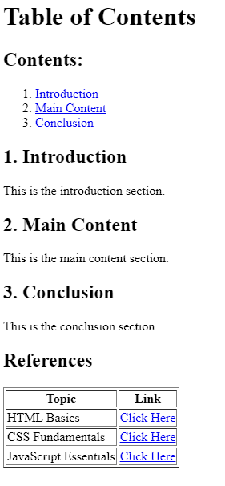

3. Create simple Forms in HTML and demonstrate the use of various form elements like input box, textarea, submit and radio buttons etc.

Code:-

<!DOCTYPE html>

<html lang="en">

<head>

    <meta charset="UTF-8">

    <meta name="viewport" content="width=device-width, initial-scale=1.0">

    <title>Simple HTML Form</title>

</head>

<body>

    <h1>Simple HTML Form</h1>

    <form action="#" method="post">

        <label for="name">Name:</label>

        <input type="text" id="name" name="name" required><br><br>

        <label for="email">Email:</label>

        <input type="email" id="email" name="email" required><br><br>

        <label for="message">Message:</label><br>

        <textarea id="message" name="message" rows="4" cols="50" required></textarea><br><br>

        <label for="gender">Gender:</label><br>

        <input type="radio" id="male" name="gender" value="male" required>

        <label for="male">Male</label><br>

        <input type="radio" id="female" name="gender" value="female">

        <label for="female">Female</label><br><br>

        <label for="age">Age:</label>

        <select id="age" name="age" required>

            <option value="">Select...</option>

            <option value="under18">Under 18</option>

            <option value="18to30">18 to 30</option>

            <option value="31to50">31 to 50</option>

            <option value="over50">Over 50</option>

        </select><br><br>

        <input type="checkbox" id="subscribe" name="subscribe" checked>

        <label for="subscribe">Subscribe to our newsletter</label><br><br>

        <input type="submit" value="Submit">

    </form>

</body>

</html>

Output:-

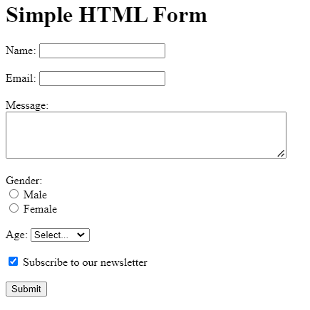

4. Demonstrate the use of cascading style sheets (CSS) (inline, internal and external) to specify various aspects of style, such as colours and text fonts and sizes, in HTML document.

Code:-

* Inline CSS

<!DOCTYPE html>

<html lang="en">

<head>

    <meta charset="UTF-8">

    <meta name="viewport" content="width=device-width, initial-scale=1.0">

    <title>Inline CSS Example</title>

</head>

<body>

    <h1 style="color: blue; font-family: Arial, sans-serif; font-size: 24px;">Heading with Inline CSS</h1>

    <p style="color: green; font-family: 'Times New Roman', serif; font-size: 18px;">Paragraph with Inline CSS</p>

</body>

</html>

Output:-

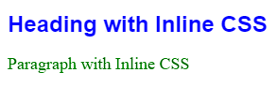

* Internal CSS

Code:-

<!DOCTYPE html>

<html lang="en">

<head>

    <meta charset="UTF-8">

    <meta name="viewport" content="width=device-width, initial-scale=1.0">

    <title>Internal CSS Demo</title>

    <!-- Internal CSS -->

    <style>

        h1 {

*color*: blue;

*font-family*: Arial, sans-serif;

*font-size*: 24px;

        }

        p {

*color*: green;

*font-family*: 'Times New Roman', serif;

*font-size*: 18px;

        }

    </style>

</head>

<body>

    <h1>Internal CSS Example</h1>

    <p>This paragraph demonstrates internal CSS.</p>

</body>

</html>

Output:-

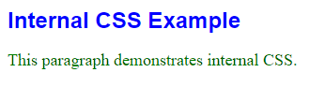

* External CSS

Code:-

<!DOCTYPE html>

<html lang="en">

<head>

    <meta charset="UTF-8">

    <meta name="viewport" content="width=device-width, initial-scale=1.0">

    <title>External CSS Demo</title>

    <link rel="stylesheet" href="./style4c.css"

</head>

<body>

    <h1>External CSS Example</h1>

    <p>This paragraph demonstrates external CSS.</p>

</body>

</html>

Style.css

h1 {

*color*: blue;

*font-family*: Arial, sans-serif;

*font-size*: 24px;

}

p {

*color*: green;

*font-family*: 'Times New Roman', serif;

*font-size*: 18px;

}

Output:-

